**Tableau Assignment**

**-Deepan Sanghavi**

**Solutions:**

1. 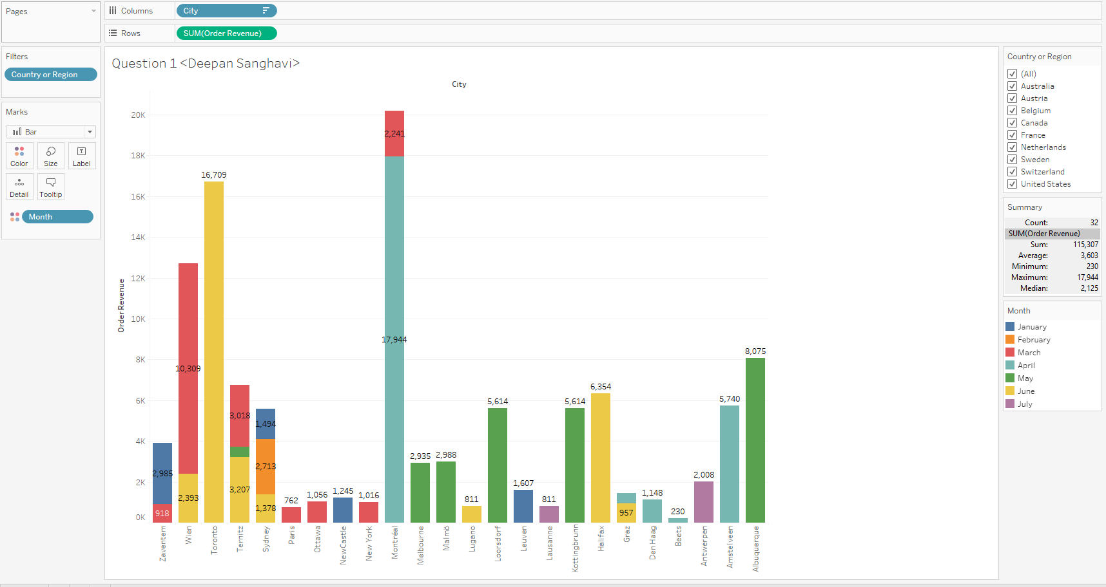
2. 